 | 

Conception of a Multi-Server Hardening Framework
Threat Modeling, Role-Based Firewall Policy, and Ansible-Based Automation

Overview
The project combines threat modeling, Linux hardening, reusable nftables firewall policies, and Infrastructure as Code principles to automate the deployment of secure server profiles for Web, Database, and Management systems. Every security control is justified through documented design decisions and validated using practical security testing.

Engineering Domain | Linux Infrastructure Security
Security Methodology | Threat Modeling + Infrastructure as Code
Project Type | Security Engineering Framework
Author | Akram Khoulid

Date: 31/07/2026
ABSTRACT
Modern Linux infrastructures often consist of servers that perform fundamentally different roles, yet they are frequently secured using identical hardening procedures and generic firewall configurations. This approach increases the attack surface, complicates maintenance, and makes large-scale security management difficult to automate consistently. Effective infrastructure security requires controls that reflect the purpose, exposure, and communication requirements of each server rather than a one-size-fits-all configuration.
This project presents the design and implementation of an Infrastructure Security Automation Framework, an enterprise-oriented solution that automates Linux server hardening and role-based firewall deployment using Ansible. The framework establishes a common security baseline shared by all servers while defining dedicated security profiles for three common infrastructure roles: Web Server, Database Server, and Management Server. Each profile is developed from a documented threat model and implemented through purpose-built nftables policies that enforce the principle of least privilege according to the responsibilities of the server.
Security policies are implemented as reusable Ansible roles and parameterized Jinja2 templates, allowing the same framework to generate different configurations through variables rather than duplicated code. This Infrastructure as Code approach ensures that deployments remain automated, consistent, repeatable, and idempotent across multiple systems while significantly reducing configuration complexity.
The framework is validated through practical security testing, including Lynis security audits, Nmap network scanning, firewall functional verification, and Ansible idempotency testing. Beyond automating server configuration, the project demonstrates a complete security engineering methodology in which threat modeling, firewall design, Linux hardening, automation, and validation are integrated into a single reproducible framework suitable for enterprise Linux environments.

PROJECT SCOPE
Modern enterprise infrastructures rarely consist of identical servers performing the same function. Web servers, database servers, and management systems each expose different services, communicate with different hosts, and present unique attack surfaces. Despite these differences, many hardening procedures rely on generic security configurations that are applied uniformly across every server, regardless of its role. While such an approach simplifies deployment, it often results in unnecessary services being exposed, overly permissive firewall policies, and security controls that fail to reflect the operational requirements of individual systems.
This project focuses on the design and implementation of an Infrastructure Security Automation Framework that addresses these limitations through automation and role-based security engineering. The framework uses Ansible as the automation platform and nftables as the firewall implementation to provide consistent, repeatable, and maintainable security configurations for Linux servers. Rather than producing a single hardening configuration for all systems, the framework defines reusable security profiles that adapt to the operational role of each server while maintaining a shared security baseline.
The scope of this project includes the design, implementation, and validation of security controls for three common enterprise server roles:
- Web Server — a publicly accessible server responsible for providing web services while exposing only the network services required for client communication.
- Database Server — an internal server designed to accept connections only from trusted application hosts while minimizing both inbound and outbound network exposure.
- Management Server — a privileged administrative system responsible for secure infrastructure management, remote administration, and controlled access to internal resources.
Each server profile is developed using a structured security engineering methodology. The process begins with identifying the server's purpose and expected communication patterns, followed by threat modeling to determine potential attack vectors. These findings are translated into security requirements that guide the design of role-specific nftables firewall policies and Linux hardening measures. Finally, the resulting configurations are implemented through reusable Ansible roles and Jinja2 templates to ensure that deployments remain automated, consistent, and idempotent.
The project also includes the implementation of a common security baseline shared across every server profile. This baseline consists of fundamental Linux hardening practices, including secure SSH configuration, kernel parameter tuning through sysctl, user and privilege management, and additional operating system security configurations that should be applied regardless of the server's function. By separating common security controls from role-specific firewall policies, the framework promotes modularity, maintainability, and reuse across different infrastructure environments.
To ensure that the implemented controls behave as intended, the framework incorporates a comprehensive validation process. Security configurations are verified using Lynis security auditing, Nmap network scanning, functional firewall testing, and Ansible idempotency verification. These validation procedures provide objective evidence that the deployed policies correctly enforce the intended security requirements and can be applied repeatedly without producing configuration drift.
The project intentionally excludes several important areas of enterprise security that are beyond its primary objective. Topics such as Security Information and Event Management (SIEM), Intrusion Detection and Prevention Systems (IDS/IPS), Endpoint Detection and Response (EDR), centralized log management, vulnerability management, cloud infrastructure provisioning, and continuous security monitoring are not addressed within this framework. While these technologies are essential components of a comprehensive security architecture, each represents a specialized discipline that warrants dedicated study and implementation.
Accordingly, this framework should be viewed as one component of a broader infrastructure engineering portfolio. Its purpose is to establish a robust foundation for automated Linux hardening and firewall engineering, while complementary projects will address monitoring, logging, vulnerability management, cloud infrastructure, and other advanced operational security capabilities.

Project Foundations
This chapter establishes the engineering foundations of the Infrastructure Security Automation Framework by defining the problem it addresses, the motivation behind its development, and the principles that guided its design. Before discussing implementation details, it is essential to understand why modern Linux infrastructures require automated, role-based security management and how this framework responds to those requirements. The chapter also introduces the project's objectives, design philosophy, high-level architecture, and the technologies selected to support its implementation, providing the conceptual basis for the remaining chapters of this report.

Background
Modern enterprise infrastructure is not a collection of identical machines. It is a heterogeneous environment where each server exists to fulfill a specific operational function — serving web traffic, storing and processing data, managing authentication, routing network connections, or providing administrative access to other systems. Each function carries a distinct risk profile, a distinct set of required network access, and a distinct set of privileges that legitimate users need to perform their work.
A web server accepts connections from the public internet on ports 80 and 443. It must be reachable by any client anywhere in the world. A database server, by contrast, should accept connections from exactly one source — the application server that queries it — on exactly one port. It has no legitimate reason to accept connections from the internet, from other database servers, or from engineering workstations. A management server exists to provide administrative access to other infrastructure and needs outbound connectivity to many machines but strict inbound restrictions to prevent it from becoming a pivot point for lateral movement.
These three machines may run the same operating system, but they are not the same machine from a security perspective. Treating them as identical — applying the same configuration, the same firewall policy, the same access controls — produces a result that is simultaneously too permissive in some areas and too restrictive in others. A firewall policy designed for a web server applied to a database server leaves database ports reachable from sources that should never reach them. A firewall policy designed for a database server applied to a web server blocks legitimate traffic and makes the service unreachable.
The recognition that security requirements are determined by operational role, not by operating system, is the foundational insight that this project builds upon.
The second driving force behind this project is scale. A company with five servers can afford to harden each one manually. A company with fifty cannot. A company with five hundred cannot even attempt it. As infrastructure grows, manual processes do not scale linearly — they break entirely. The engineer who hardened five servers carefully and correctly will introduce inconsistencies at fifty. At five hundred, consistency becomes impossible without automation.
Automation is not a convenience in modern infrastructure security. It is the only mechanism by which consistent security can be maintained at scale. The alternative — manual configuration applied individually to each machine — produces environments where security is measured not by policy but by the last engineer who touched each server and how careful they were that day.
This project addresses both problems simultaneously: the need for role-aware security policies and the need to apply those policies automatically, consistently, and verifiably across any number of servers.

Problem Statement
Manual Linux server hardening suffers from five fundamental limitations that make it unsuitable as a production security practice beyond small environments.
Configuration drift
A server hardened manually today will not remain in its hardened state indefinitely. System updates modify configuration files. New packages introduce new services with default — often permissive — settings. Engineers making emergency changes under time pressure skip hardening steps. Over weeks and months, the gap between the intended security state and the actual security state widens silently. This phenomenon is called configuration drift, and it is invisible without continuous monitoring and comparison against a known baseline.
Manual hardening produces a point-in-time result. It makes no provision for maintaining that result over the server's operational lifetime.
Inconsistent firewall policies
When firewall rules are written by hand for each server individually, the result is a fleet of machines with subtly different policies. One engineer allows ICMP from any source. Another allows it only from the management network. A third disables it entirely. None of these decisions is necessarily wrong in isolation, but the inconsistency means that the security posture of the fleet cannot be understood or audited without examining each machine individually.
Inconsistency is not merely an administrative inconvenience. Attackers actively probe for inconsistencies because they represent the gaps between intended policy and actual configuration.
Human error
Manual configuration is error-prone regardless of the engineer's skill level. A missed directive in sshd_config leaves password authentication enabled on a server that was supposed to require keys. A firewall rule with an incorrectly specified subnet allows traffic from a broader range than intended. An auditd rule with a typo silently fails to load and leaves a gap in audit coverage.
These errors are not the result of incompetence — they are the predictable consequence of asking humans to perform repetitive, detail-oriented configuration tasks without mechanical verification. The only reliable defense against human error in configuration is automation.
Poor scalability
Hardening one server manually takes an experienced engineer several hours when done correctly — examining the default configuration, applying hardening directives, configuring the firewall, setting up intrusion detection, deploying audit rules, and verifying the result. Multiplying this by the number of servers in a growing infrastructure quickly produces a bottleneck where security work cannot keep pace with infrastructure growth.
The consequence is predictable: new servers are deployed with incomplete hardening because the team does not have capacity to harden each one properly before it enters service. The backlog of unhardened servers grows faster than it is addressed.
Maintenance challenges
When a new security requirement emerges — a new audit rule to add, a firewall policy change, a new SSH directive recommended by a security advisory — applying that change manually across a fleet of servers is a project in itself. Each server must be accessed individually, the change applied, and the result verified. The probability that at least one server is missed or incorrectly modified is directly proportional to the fleet size.
In practice this means that security improvements are applied inconsistently across infrastructure, creating a permanently uneven security posture where some servers are current and others are not.

Why Traditional Linux Hardening Does Not Scale
The traditional approach to Linux hardening — documented in CIS Benchmarks, security guides, and operational runbooks — treats hardening as a checklist applied uniformly to every server. Enable these settings. Disable these services. Configure this firewall. Apply these kernel parameters. The checklist is the same regardless of what the server does.
This approach has a fundamental conceptual flaw: it conflates the operating system with the server's operational role. The hardening decisions that make sense for a server depend not on which operating system it runs but on what that server is responsible for and what threats are relevant to that responsibility.
Consider the firewall policy. A checklist approach might specify: allow SSH on port 22, allow established connections, drop everything else. This policy is reasonable for a management server. Applied to a web server it breaks the service — port 80 and 443 are not allowed. Applied to a database server it is too permissive — SSH should not be reachable from the internet even if the port is not in use.
The correct approach is to derive firewall policy from a threat model specific to the server's role. The threat model asks: what connections does this server legitimately need to accept? From where? What connections does it need to initiate? What are the realistic attack vectors given its network position and the services it runs? The answers to these questions produce a firewall policy that is appropriate to the role — neither too permissive nor unnecessarily restrictive.
Role-based security policy is the standard in enterprise security architecture. Access control systems grant permissions based on role, not identity. Network segmentation isolates segments by function. Firewall policies at the network level are defined per zone. Extending this principle to host-level security — where the firewall policy applied to each server is determined by its operational role — is the natural application of an already-established security principle.
The framework built in this project operationalizes role-based security policy at the host level and automates its deployment. The result is a system where adding a new server to the infrastructure requires only identifying its role and running the appropriate playbook — the correct security policy is applied automatically without requiring an engineer to reason about hardening decisions for each individual machine.

Project Objectives
The framework is designed to achieve six specific objectives. Each objective addresses one of the limitations identified in section 1.2 or one aspect of the role-based security model described in section 1.3.
Automate the common hardening baseline
Every server, regardless of its role, receives a consistent set of security hardening measures, including SSH daemon hardening, kernel parameter configuration through sysctl, user and privilege management, and other system-wide security settings. This baseline is deployed automatically using Ansible, ensuring that every server starts from the same secure foundation. By automating these configurations, the framework eliminates repetitive manual work, reduces the risk of human error, and guarantees consistent security across all managed systems.
Implement role-based firewall policies
Three server profiles — web server, database server, and management server — each receive a firewall policy derived from a threat model specific to that role. The policies are designed from first principles using nftables and implemented as Jinja2 templates that can be parameterized for different environments without modifying the underlying policy logic.
Ensure repeatability
Running the framework against a fresh server produces an identical result every time. The hardened state is deterministic — it is defined by the framework's configuration, not by the engineer who runs it. Any engineer with access to the framework can produce the same result on any server without specialized knowledge of individual hardening steps.
Maintain idempotency
Running the framework multiple times against the same server produces no changes after the first run. The framework detects the current state of each configuration item and only modifies items that deviate from the desired state. This property enables the framework to be run periodically as a drift correction mechanism — any configuration change made outside the framework is detected and corrected automatically.
Reduce manual intervention
From initial deployment to ongoing maintenance, the framework minimizes the number of manual steps required to maintain a secure fleet. Adding a new server requires only adding it to the inventory and running the appropriate playbook. Applying a security policy change across the entire fleet requires modifying one variable or template and running the playbook.
Validate deployed security controls
The framework's security claims are verified through practical testing rather than assumed from configuration. Lynis security auditing produces quantitative before-and-after scores. nmap scanning verifies that firewall policies enforce their intended access controls. Idempotency testing confirms professional-grade Ansible implementation. Security is not declared — it is demonstrated.

Selected Technologies
Each technology in this framework was selected to fulfill a specific engineering requirement. The selection criteria were maturity, production relevance, and alignment with the framework's design principles.
Ubuntu Server 24.04 LTS
Ubuntu Server is selected as the target operating system because it is one of the two most widely deployed Linux distributions in enterprise and cloud environments — alongside Red Hat Enterprise Linux. The LTS designation guarantees five years of security updates, making it appropriate for production deployments where stability and long-term support matter. The framework targets 24.04 LTS specifically because it ships with nftables as the default firewall subsystem and OpenSSH 9.x, which introduces the penalty-based authentication rate limiting used in the fail2ban configuration.
Ansible
Ansible is selected as the automation engine because it is agentless — it requires no software installation on target servers beyond Python and an SSH connection. This property is important for a security hardening framework: installing an agent on every server before hardening it introduces a dependency and an attack surface that defeats part of the framework's purpose. Ansible connects over SSH, executes tasks, and leaves no persistent process running on the target. It is also the most widely adopted infrastructure automation tool in enterprise Linux environments, making skills developed with it directly transferable to production roles.
nftables
nftables is selected as the firewall tool because it is the current Linux kernel standard, replacing iptables on all major distributions. Its native support for sets and maps enables efficient implementation of role-specific policies without duplicating rules. Its unified handling of IPv4 and IPv6 in the inet family eliminates the dual-ruleset problem that iptables required. Its atomic rule updates eliminate the brief unfiltered window that iptables reloads produced. For a framework designed to deploy different firewall policies per role, nftables provides the data structures and performance characteristics that iptables cannot.
Jinja2
Jinja2 is Ansible's native templating engine. It is selected because it allows configuration files — including nftables rulesets — to be expressed as templates with variable substitution. A single nftables template can produce different rulesets for different environments by substituting different values for interface names, IP addresses, and allowed ports. Without templating, separate static configuration files would be required for each environment, eliminating the reusability principle.
OpenSSH
SSH is the transport mechanism for both Ansible's communication with target servers and for administrative access to hardened servers. It is selected not as an alternative to other protocols but because it is the universal standard for secure remote administration of Linux systems. The SSH hardening applied by the framework — key-only authentication, disabled root login, group-based access restrictions — is a direct application of the least privilege principle to the administrative access layer.
Lynis
Lynis is an open-source security auditing tool that performs a comprehensive assessment of a Linux system's security configuration and produces a scored report. It is selected as the validation tool because it provides a quantitative measure of security posture — a before score and an after score — that demonstrates the concrete security improvement produced by the framework. Lynis is also widely used in enterprise security auditing, making its output format familiar to security engineers and auditors.
nmap
nmap is selected for firewall policy validation because it provides direct evidence that firewall rules enforce their intended access controls. Running nmap against a hardened server from different source positions verifies which ports are reachable from which locations — confirming that the deployed policy matches the designed policy. This validation cannot be performed by examining configuration files alone; it requires actually attempting the connections that the firewall is intended to block.
VirtualBox
VirtualBox is selected as the virtualization platform for the development and testing environment because it provides the ability to create multiple isolated virtual machines on a single physical host without cloud infrastructure costs. The three target server VMs and the control node can be created, snapshotted before hardening, and restored to their pre-hardening state for repeated testing without requiring external resources. VirtualBox is explicitly a development and testing platform — the framework itself is environment-agnostic and can be applied to physical servers, cloud VMs, or any other Linux Server installation without modification.

Security Engineering Methodology & Framework Architecture
Chapter 1 defined the problem this project addresses, its objectives, and the technologies selected to meet them. This chapter shifts from what the project builds to how it secures it. It first presents the infrastructure the project protects, then derives a threat model from that infrastructure, then describes the engineering workflow used to translate identified threats into enforced configuration, and finally consolidates the result into a layered, role-based security profile for each server. This order is deliberate: security decisions made before the system they protect is understood are decisions made by convention rather than by engineering. Every control introduced later in this chapter is traceable back to a specific element of the architecture described here, and to a specific threat identified against it.

Infrastructure Architecture
The infrastructure secured by this project consists of three roles arranged around a single administrative entry point: an Administrator, a Management & Automation Server acting as an Ansible control node, and two managed servers — a Web Server and a Database Server. Figure 2.1 shows the resulting topology, organized into three zones. The Administrator zone holds the only human operator and the only private SSH key in the system. The Control zone consists solely of the Management & Automation Server — the Ansible control node — which is the single system authorized to push configuration to the managed servers. The Managed zone contains the Web Server and Database Server, which receive configuration but never initiate it.
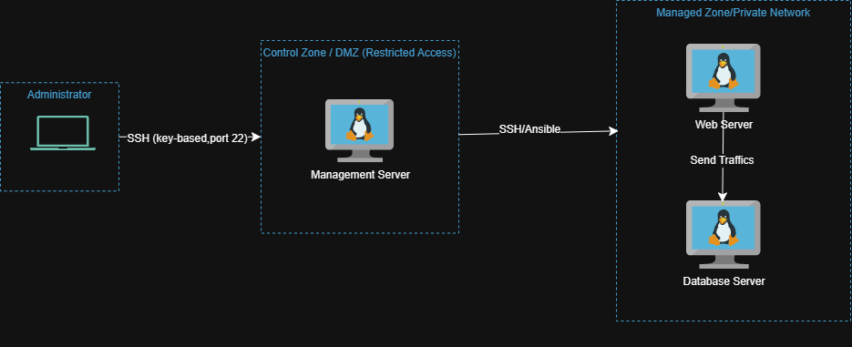
Figure 1:Infrastructure Architecture
Two properties of this topology drive the rest of the chapter's analysis. First, administrative access is single-entry: the Administrator never connects directly to the Web Server or Database Server, only to the control node. This concentrates the highest-value credential — the administrator's SSH key — into one relationship instead of three, and gives the project one clear boundary to harden rather than several. Second, control flow is one-directional: configuration and commands move from the control node down to the managed servers, never the reverse. The one exception is the Web Server's connection to the Database Server, which is application traffic, not management traffic, and is governed by a separate set of rules.
The Control zone is deliberately placed in a DMZ rather than a fully private network. This is an intentional exposure, not an oversight: the control node must be reachable by the administrator, and rather than exposing every managed server to remote administration, this design exposes exactly one, tightly hardened host and keeps the Web Server and Database Server unreachable from outside the Managed zone. This concentrates administrative risk into a single, deliberately exposed and hardened host rather than distributing SSH access across every managed server. The trade-off is a single point of failure: compromise or unavailability of the control node affects the entire managed fleet. This is an accepted trade in security engineering — it is more tractable to harden and monitor one carefully controlled entry point than to defend many equally well — but it is a trade-off, not a free improvement, and is mitigated in production environments through bastion redundancy or brokered-access services (e.g., AWS Systems Manager, Azure Bastion) that remove the exposed listening port entirely. This project uses the single-bastion model in its foundational form, appropriate to its scope. A VPN-gated control node, removing public exposure entirely, is a natural extension of this design and is treated as a separate project rather than within this report's scope.
This architecture is the input, not the output, of the chapter's security work. It is described here in full before any control is proposed, because a control can only be justified by referring back to a threat, and a threat can only be identified by referring back to a system that is already fully specified. Section 2.2 uses this exact topology to derive that threat model.

Threat Modeling Methodology
Before any hardening measure or firewall rule can be justified, the operational role of a server must be analyzed to identify the threats realistic for that role. This project treats threat modeling as a per-server methodology rather than a single infrastructure-wide exercise: a generic threat list would obscure the fact that different servers face fundamentally different risks depending on what they do and who they legitimately talk to. The methodology defined here is applied to each server individually in Chapters 4 through 6; this section defines the questions and reasoning process common to all of them.
For any given server, the threat model answers three questions, in order:
What connections does this server legitimately need, in each direction? This is the foundation of the entire model — everything the server does not need is, by definition, something a firewall policy should deny. This question must be answered independently for inbound and outbound traffic, since a server's legitimate inbound sources are rarely identical to its legitimate outbound destinations.
What would an attacker attempt if they gained a foothold on this specific machine? This question anticipates realistic next steps — lateral movement toward other servers, privilege escalation, credential reuse — grounded in the server's actual position in the architecture, rather than a generic list of malware behaviors that could apply to any machine.
What is the consequence if this server is compromised? This determines how aggressively the server's blast radius must be contained, independent of how likely a compromise is judged to be. A low-probability, high-consequence server (such as one holding administrative authority over others) may warrant stricter containment than a higher-probability, lower-consequence one.
The output of applying these three questions to a server is not a narrative description but a concrete, technology-agnostic requirement set: which ports must be open, which source and destination addresses are legitimate, and what would constitute an anomalous or unauthorized connection attempt for that server. These requirements are deliberately expressed without reference to any specific tool — they describe what must be true, not how it will be enforced. This distinction matters because it is what allows the same methodology to be applied consistently to servers with very different roles: the questions stay identical from server to server, even though the answers — and therefore the resulting firewall policy and hardening baseline — differ sharply. Chapters 4 through 6 apply this exact methodology to the Management Server, Web Server, and Database Server respectively, and Section 2.3 describes the workflow that turns each resulting requirement set into an enforced configuration.

Security Engineering Workflow
The framework follows a six-stage workflow from initial threat analysis to verified deployment. Each stage produces an output that becomes the input for the next stage. The workflow is linear during design and cyclical during operation — once deployed, the framework can be re-run at any time to correct drift or apply policy updates.
Stage 1 — Threat Model
Before any configuration is written, the operational role of the target server is analyzed to identify the realistic threats it faces. The threat model asks: what network connections does this server legitimately need? What attack patterns are relevant given its network position? What would an attacker attempt if they gained a foothold on this machine? The answers define the security requirements that all subsequent stages must satisfy.
Stage 2 — Security Requirements
The threat model produces a set of security requirements specific to the server role. These requirements are expressed in engineering terms: which ports must be open, which must be closed, which source addresses are legitimate, what constitutes an authentication failure, which files and operations must be audited. Requirements at this stage are role-specific and technology-agnostic — they describe what must be true without specifying how it will be achieved.
Stage 3 — Common Hardening Baseline
A set of hardening measures applicable to every server regardless of role is defined and implemented. The baseline covers the operating system, SSH daemon, kernel parameters, user management, intrusion detection, and audit logging. It addresses threats common to all servers — brute force attacks, privilege escalation, unauthorized access — that are relevant regardless of the server's specific function.
Stage 4 — Role-Based Firewall Policy
The security requirements from Stage 2 are translated into a specific nftables firewall policy for each server role. The policy is implemented as a Jinja2 template parameterized by variables so that environment-specific values — IP addresses, interface names, allowed ports — can be adjusted without modifying the policy logic. The template produces a different ruleset for each role while sharing the same structural patterns.
Stage 5 — Ansible Automation
The common baseline and role-specific policies are implemented as Ansible roles. The roles encode the security requirements as tasks, templates, and variables. Running the appropriate playbook applies the complete security configuration — baseline plus role-specific policy — to the target server automatically. No manual steps are required beyond running the playbook command.
Stage 6 — Validation
The deployed security configuration is verified through practical testing. Lynis auditing produces a quantitative security score that documents the improvement from the baseline Ubuntu installation. nmap scanning verifies that the firewall policy enforces its intended access controls by confirming which ports are reachable from which sources. Idempotency testing confirms that re-running the playbook produces no changes, validating the professional quality of the Ansible implementation.
The relationship between stages is not merely sequential — it is traceable. Every firewall rule in Stage 4 can be traced back to a specific security requirement from Stage 2, which can be traced back to a specific threat identified in Stage 1. This traceability is what distinguishes engineered security from security by convention.
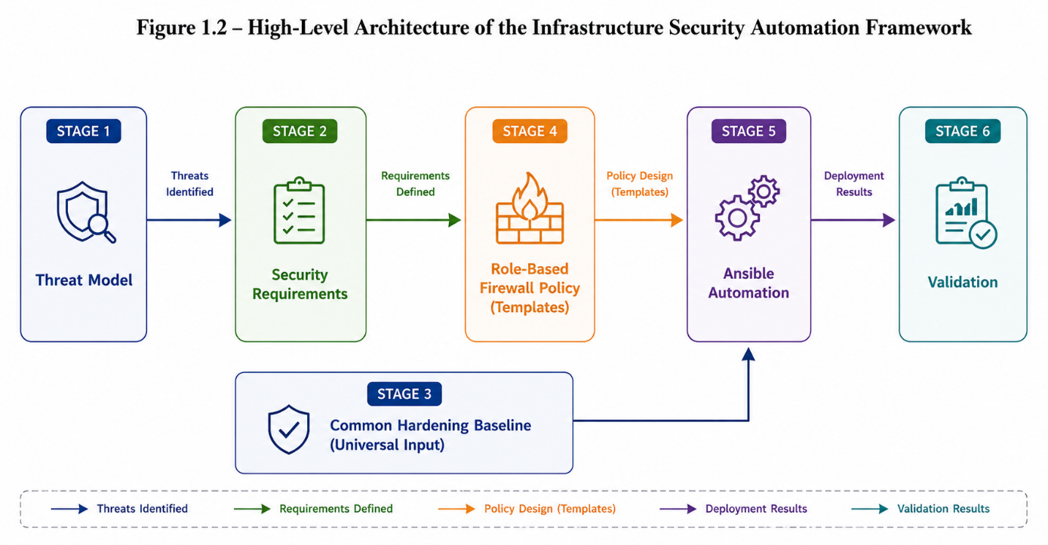
Figure 2:Security Engineering Workflow of the Proposed Framework

Security Layers
The controls produced through the workflow in Section 2.3 do not rely on any single mechanism holding. They are organized into layers, so that the failure of one does not result in the compromise of the whole system — a principle referred to as defense in depth.
- Perimeter / Access Layer — key-based SSH authentication for the administrator, exclusively to the Management Server; password authentication is disabled entirely.
- Network Layer — role-specific nftables policy on each server, restricting both inbound and outbound traffic to exactly what that server's threat profile (Section 2.2) defines as legitimate.
- Host Layer — OS-level hardening applied to every server (user and group discipline, service minimization, kernel parameter tuning), independent of role.
- Automation Layer — Ansible playbooks that enforce the baseline and firewall policy consistently and repeatably, removing manual configuration drift as a source of unmodeled risk.
A layer's purpose is not to assume the layer "above" it is unbreakable — it is to assume the opposite. The Network Layer's role-specific firewall rules, for instance, are not designed on the premise that the Management Server can never be compromised; they exist precisely because a compromise anywhere in the stack — whether at the perimeter, at the application level on the Web Server, or through lateral movement between servers — should not automatically translate into unrestricted reach across the rest of the architecture. A firewall on the Database Server does not need to withstand a fully compromised control node with legitimate authority to change it; it needs to withstand every other path to that server, which is the majority of realistic attack paths in practice

.2.5 Role-Based Security Profiles
The threat model, workflow, and layered controls above converge into a distinct security profile for each server — the concrete, per-role answer to "what is this machine allowed to do, and what protects it."
 | Management Server (Ansible Control Node) | Web Server | Database Server
Inbound allowed | SSH (key-based) from Administrator only | Application traffic (public), configuration pushes from Management Server | Application queries from Web Server, configuration pushes from Management Server
Outbound allowed | SSH/Ansible to Web Server and Database Server | Queries to Database Server, on application port only | None
Primary exposure | Internet-facing (DMZ), single point of administrative entry | Public-facing, application layer | Not directly reachable from outside the managed zone
Highest-consequence threat | Loss of control over the entire managed zone | Application-layer compromise used as a pivot | Direct data exposure
Key mitigating layers | Perimeter (key-only SSH), Monitoring (audit logging) | Network (restricted outbound to DB only), Host hardening | Network (deny-by-default inbound and outbound), Host hardening
This table is the practical output the rest of the report builds on: Chapter 3 implements the Automation Layer that enforces these profiles, and the firewall policy each server receives is a direct translation of the row describing it here. No profile is generic — each is derived from that server's specific threat model in Section 2.2, which is what makes the resulting configuration defensible rather than conventional.

Scope Boundaries and Limitations
The architecture, threat model, and controls described in this chapter are deliberately bounded. This section states those boundaries explicitly, distinguishing decisions made for scope reasons from genuine limitations of the design, so that neither is mistaken for an oversight.
Single point of administrative failure. The Management Server is the sole system authorized to alter the Web Server and Database Server, and its compromise or unavailability affects the entire managed zone. This is an accepted trade-off, not an unaddressed risk: concentrating administrative authority into one carefully hardened host is more tractable to secure and monitor than distributing SSH access across every managed server. In production environments this single point of failure is typically mitigated through bastion redundancy or brokered-access services (e.g., AWS Systems Manager, Azure Bastion); this project implements the single-host model in its foundational form, appropriate to its scope.
No network-layer isolation beyond the host. This project does not implement a NAT gateway, DMZ subnet separation, or VPN-gated access as distinct network infrastructure. The Management Server's exposure model is treated as a stated assumption rather than a built and defended subsystem. Consequently, questions such as how managed servers would receive software updates without direct internet access, or how a public-facing web application would be safely exposed through port-forwarding, are outside this project's scope. This boundary was chosen deliberately: the project's contribution is the threat-driven automation and hardening layer, not the surrounding network architecture, and combining both would dilute the depth achievable on either.
No monitoring or audit logging layer. The Security Layers defined in Section 2.4 do not include centralized logging, audit trails, or intrusion detection. Actions taken through the Management Server are therefore not independently attributable after the fact in this implementation. This is a limitation of the current scope rather than a design position — attributability is valuable and would strengthen the Perimeter and Automation layers, but implementing it correctly (log integrity, centralized collection, retention) is a substantial effort in its own right and was not undertaken here.
Web Server traffic is internal, not public. The Web Server's threat profile assumes application traffic originates from within the private lab network or from the local host machine running the lab environment (Chapter 4), not from public internet users. A second network adapter is used solely to allow testing and verification from the host machine, and does not constitute public exposure — no adapter on the Web Server is reachable from outside the local machine hosting the lab. Serving genuine public traffic would require a distinct design (a reverse-proxy), which reintroduces the network-layer questions excluded below. This project validates the automation and firewall methodology under a non-public-traffic assumption; extending it to genuine public exposure is a natural next step rather than a correction.
Relationship to future work. Each limitation above corresponds to a specific, identified extension: network segmentation and NAT/VPN gating, public-facing exposure with role-scoped port-forwarding, and centralized monitoring are the planned subject of a larger follow-on project building on this one's automation and hardening foundation. Stating these boundaries here is intended to make clear that they were recognized and reasoned about during design, not discovered as gaps after the fact.

Ansible Automation Architecture
Chapter 2 defined what must be enforced on each server and why. This chapter explains how Ansible, as a tool, turns that into running configuration — its core concepts and syntax. Chapters 4–6 then apply this tool concretely to each server.

Control Node and Inventory
Ansible is agentless: no software runs permanently on the Web or Database Server waiting for instructions. The Management Server connects over ordinary SSH, executes what it needs, and disconnects — exactly as an administrator would by hand. This means Ansible's access model is the trust relationship from Chapter 2, not an addition to it: whatever SSH permits is exactly what Ansible can do, nothing more.
The inventory is the file that tells Ansible which servers exist and how they're grouped. It is written in INI-style syntax, by default at inventory/hosts.ini:
[management]
mgmt ansible_host=127.0.0.1 ansible_connection=local

[web]
web1 ansible_host=192.168.1.10

[db]
db1 ansible_host=192.168.1.20

[all:children]
management
web
db
Reading this syntax:
- [management], [web], [db] are group headers. Everything listed under a header belongs to that group.
- mgmt, web1, db1 are aliases — names Ansible will use to refer to that host; they don't have to match the real hostname.
- ansible_host= tells Ansible the actual IP/address to connect to for that alias.
- ansible_connection=local is a special case meaning "don't SSH, this is the machine Ansible is running on" — used for the control node itself if it's included in its own inventory.
- [all:children] is a group-of-groups: it says "the group all consists of the groups management, web, and db combined." This is what lets a later command target literally everything in one word (all) without listing every host.
Why this matters beyond syntax: the shape of the inventory should mirror the shape of the threat model. Chapter 2 established that these three servers have different legitimate needs. The inventory is where that distinction first becomes addressable in automation — a later instruction can say "do this to web only" or "do this to all," and that targeting only works because the grouping exists here, first.
The very first thing you test, before writing any real logic, is whether Ansible can actually reach every host:
bash
ansible all -m ping
Reading this command: ansible is the ad-hoc command-line tool (as opposed to ansible-playbook, used later for real automation). all is the group being targeted — here, everything. -m ping says "run the module named ping" — not a network ICMP ping, but an Ansible module that simply confirms it can connect and execute Python on the target. A healthy result looks like:
web1 | SUCCESS => {"ping": "pong"}
db1 | SUCCESS => {"ping": "pong"}
mgmt | SUCCESS => {"ping": "pong"}
If even one host fails here, everything built afterward will silently fail for that host too — which is why this is the first checkpoint, not an afterthought.

Project Structure and Roles
Ansible lets you write one giant file of instructions, but this project deliberately uses roles, because roles let automation logic mirror the same per-server distinctions Chapter 2 already made.
A role is a directory, structured in a fixed layout Ansible recognizes automatically:
roles/
└── firewall/
├── tasks/
│ └── main.yml
├── templates/
│ └── nftables.conf.j2
└── handlers/
└── main.yml
Each subfolder has a fixed meaning Ansible expects:
- tasks/main.yml — the actual steps to run (covered in 3.5).
- templates/ — files that get filled in with variables before being sent to a server (covered in 3.4).
- handlers/main.yml — actions that only run if a task actually changed something (covered in 3.5).
This project uses at least two roles:
- common — baseline hardening tasks applied identically to every server.
- firewall — the firewall policy logic. Importantly, this is written once, as a single role — not three separate roles for three servers. What differs between servers is not the logic, but the data fed into that logic (Section 3.3).
A playbook is the file that connects roles to inventory groups — the instruction "apply this role, to this group." Written in YAML, by default site.yml:
yaml
---
- hosts: all
become: yes
roles:
- common

- hosts: web
become: yes
roles:
- firewall

- hosts: db
become: yes
roles:
- firewall
Reading this syntax: each - starting with hosts: is a play — one unit of "target this group, do these roles." hosts: all targets the group-of-groups from the inventory. become: yes means "run as root" (via sudo), since firewall changes require elevated privilege. roles: lists which role(s) apply in that play, by folder name. Reading top to bottom: first, common runs on every server; then, firewall runs on web; then, separately, firewall runs on db — same role, applied twice, to two different groups.
This is run with:
bash
ansible-playbook site.yml
ansible-playbook (distinct from the ansible ad-hoc command used for the ping test) is the tool that executes a full YAML playbook rather than a single module.
Why this structure pays off: if a new baseline requirement appears, it's added once in common and reaches every server automatically. If a new server role were ever added to the architecture, it would need only an inventory entry and variables — the firewall role's logic itself would not change. Roles let the automation scale with the number of requirements, not the number of servers.

Variables and Host/Group Scoping
Section 3.2 established that firewall is written once, as a single role, even though the Web Server and Database Server need different rules. This section explains the mechanism that makes that possible: variables.
A variable in Ansible is just a named value that a task or template can reference instead of a hard-coded number or string. The same task, run against two different hosts, can produce two different results if it pulls its actual values from variables rather than writing them directly into the task itself. This is the core idea behind everything in this section: write the logic once, vary the data per host or per group.
Ansible looks for variables in specific, predictable locations. The two used in this project are:
group_vars/ — variables that apply to every host in a given inventory group. A file named after the group is read automatically:
group_vars/
├── all.yml
├── web.yml
└── db.yml
group_vars/web.yml (illustrative, not real values):
yaml
---
allowed_inbound_port: 8080
allowed_outbound_destination: "{{ groups['db'][0] }}"
allowed_outbound_port: 5432
group_vars/db.yml (illustrative):
yaml
---
allowed_inbound_sources:
- "{{ hostvars[groups['web'][0]]['ansible_host'] }}"
allowed_inbound_port: 5432
Reading this syntax: the file name (web.yml, db.yml) must exactly match a group name from the inventory — this is how Ansible knows which variables belong to which hosts, with no extra configuration needed. {{ }} is Jinja2 interpolation syntax (explained fully in 3.4) — here it's being used inside a variable file itself to reference another host's data, for example pulling the Web Server's real address into the Database Server's "allowed source" list, rather than typing an IP twice in two places and risking them drifting apart.
host_vars/ works identically, but for a single specific host rather than a whole group — used when one host needs an exception the rest of its group doesn't share, named after the host alias (host_vars/web1.yml).
Why this section matters more than its syntax suggests: this is the exact point where Chapter 2's per-server requirement sets become code. The port numbers and source addresses that Section 2.2's threat model derived for each server role are not re-derived here — they are simply typed once, into the correct group's variable file. The firewall role's task logic (3.5) will never mention a specific port number at all; it will only ever say "use whatever allowed_inbound_port is for this host," and Ansible resolves that differently depending on which group the current target host belongs to. This is what "one role, three outcomes" actually means in practice.

3.4 Templates and Policy Generation (Jinja2)
A template is a file that looks almost like the real configuration file it will become, except some values are placeholders written in Jinja2 syntax — {{ variable_name }} — that get substituted with actual values at run time. Ansible template files conventionally end in .j2 and live in a role's templates/ folder.
Illustrative nftables template, roles/firewall/templates/nftables.conf.j2:
jinja2
table inet filter {
chain input {
type filter hook input priority 0; policy drop;

ct state established,related accept
ct state invalid drop

tcp dport {{ allowed_inbound_port }} accept
{% if allowed_inbound_sources is defined %}
{% for source in allowed_inbound_sources %}
ip saddr {{ source }} accept
{% endfor %}
{% endif %}
}

chain output {
type filter hook output priority 0; policy drop;

ct state established,related accept
ip daddr {{ allowed_outbound_destination | default('0.0.0.0/0') }} tcp dport {{ allowed_outbound_port | default(0) }} accept
}
}
Reading the Jinja2-specific syntax, since this is the part that's new:
- {{ allowed_inbound_port }} — simple substitution: replaced directly with whatever that variable resolves to for the current target host.
- {% if ... %} ... {% endif %} — a conditional block: the enclosed lines are only included in the final output if the condition is true (here, only if allowed_inbound_sources was actually defined for this host — the Web Server's variable file might not define it the same way the Database Server's does).
- {% for source in allowed_inbound_sources %} ... {% endfor %} — a loop: repeats the enclosed line once per item in the list, meaning a Database Server allowed by multiple source addresses gets one ip saddr ... accept line per address, generated automatically rather than hand-written.
- | default('0.0.0.0/0') — a filter: supplies a fallback value if the variable is undefined, so the template doesn't break if a particular host's variable file omits something optional.
The task that actually renders this template onto a server (detailed fully in 3.5) uses Ansible's template module, in essence:
yaml
- name: Deploy nftables ruleset
template:
src: nftables.conf.j2
dest: /etc/nftables.conf
What makes this the central mechanic of the whole project: this one file produces a genuinely different, correct ruleset for the Web Server and the Database Server, because Ansible renders it once per host, substituting that host's own group and host variables each time. Nothing in the template itself contains a real IP or port — those live entirely in 3.3's variable files, which is exactly why a new server role could be added later by writing a new group_vars file, without touching this template at all.

Tasks, Handlers, and Execution Flow
A task is one concrete action Ansible performs, written as a module call. The firewall role's tasks/main.yml contains at minimum:
yaml
---
- name: Deploy nftables ruleset
template:
src: nftables.conf.j2
dest: /etc/nftables.conf
notify: Reload nftables
name: is a human-readable label shown in output. template: is the module (from 3.4) that renders the .j2 file and writes it to dest:. notify: doesn't run anything itself — it flags a handler to run, but only if this task actually changed the file.
A handler, in handlers/main.yml:
yaml
---
- name: Reload nftables
service:
name: nftables
state: reloaded
The name under notify: must match the handler's name: exactly — that string is the link between them. Handlers only fire at the end of a play, and only once, even if multiple tasks notify the same handler — which avoids reloading the firewall repeatedly during one run.
Execution flow, end to end, per host: Ansible connects over SSH → runs the common role's tasks → runs the firewall role's tasks → renders the template using that host's variables → compares the rendered result to what's already on disk → if different, writes the file and queues the handler → at the end of the play, runs any queued handlers once.

Idempotency and Validation Approach
Idempotent means: running the same playbook twice produces the same end state, and the second run reports no changes. This isn't automatic magic — it's a property of using proper modules (template, service) instead of raw shell commands, since Ansible checks current state before acting rather than blindly re-executing.
Validation for this project (referenced back to Chapter 2's Stage 4) is simply:
bash
ansible-playbook site.yml
ansible-playbook site.yml
First run shows changed; second run should show changed=0 across all hosts. That's the proof the automation is correct and stable, not just working once.

Environment Setup and Server Provisioning
Chapter 3 established the mechanics of Ansible in the abstract — inventory, roles, variables, templates, tasks, and idempotency. This chapter builds the concrete environment those mechanics operate on: three virtual machines, sized and networked according to their roles in the architecture defined in Chapter 2, brought to a shared operational baseline before any Ansible task is run against them. The chapter ends at the exact checkpoint Chapter 3 identified as foundational — ansible all -m ping succeeding against all three hosts. Chapter 5 begins from that point, applying the threat-driven framework to each server individually.

Resource Allocation
Virtual machine resources were allocated proportionally to each server's operational role rather than uniformly, reflecting the same role-based reasoning applied throughout this report.
Server | vCPU | RAM | Disk | Reasoning
Management (control node) | 1 | 1GB | 8GB | Runs only Ansible and project files; storage and memory needs do not grow over the project's lifetime.
Web Server | 1 | 2GB | 10GB | Runs an active service with moderate runtime and log footprint.
Database Server | 1 | 2GB | 20GB | The only role with open-ended storage growth (data, indexes, logs); allocated the largest disk and matched RAM to support in-memory caching typical of database workloads.
All three virtual machines were capped at a single vCPU, a constraint imposed by the host machine (Intel Core i7-8650U, 4 physical cores) rather than a role-based decision. Running three or more VMs concurrently on a mobile quad-core processor makes single-core allocation a deliberate choice to preserve host responsiveness and avoid CPU contention between VMs, rather than an oversight in sizing. This is stated explicitly here because it is a lab-environment constraint specific to the hardware available, and should not be read as a recommendation for production sizing, where CPU allocation would instead be driven by expected request/query load per role rather than host-side scarcity.
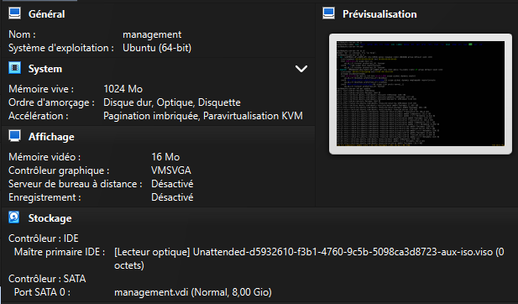
Figure 3: Virtualbox stting for management server
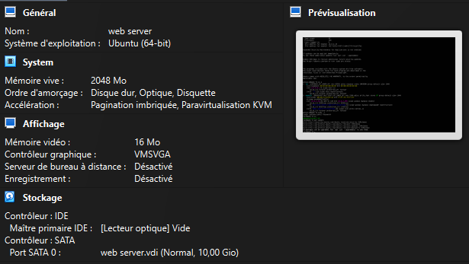
Figure 4:Virtualbox stting for web server
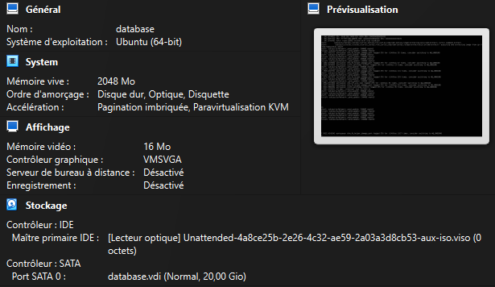
Figure 5:Virtualbox stting for database server

Network Topology for the Lab Environment
Each VM is provisioned with two or three network adapters depending on its role, and it is important to keep the purpose of each adapter distinct, since conflating them would misrepresent the architecture's actual trust boundaries.
- NAT adapter (all three VMs, temporary in purpose) — provides outbound-only internet access, used exclusively to install required packages (OpenSSH, Python 3, Ansible). VirtualBox's default NAT behavior permits no inbound connection through this adapter.
- Internal Network adapter (all three VMs, permanent) — connects Management, Web, and Database Servers to a single isolated private network segment, with no route to the host machine's real network or the internet. This is the network on which the architecture defined in Chapter 2 actually operates: SSH from Management to Web/DB, and the servers' mutual traffic, occur exclusively here.
- Host-only or Bridged adapter (Management Server and Web Server only) — allows reachability from the physical Windows machine running the lab, for administrative SSH access to the Management Server and browser-based testing of the deployed application on the Web Server.
The third adapter reflects the practical reality of testing and administering a lab environment from the physical machine hosting it — it does not represent internet-facing exposure, and does not alter the trust model established in Chapter 2. The Database Server has no host-reachable interface at all, consistent with its threat profile: it remains reachable only by the Web Server (application traffic) and the Management Server (configuration pushes).

Static IP Assignment
Each VM's adapters serve distinct purposes (Section 4.2), and their addressing reflects that distinction: the NAT and host-reachable adapters use whatever addressing VirtualBox assigns automatically, while the Internal Network adapter — the network the actual architecture operates on — is assigned a fixed static IP on each host, so that inventory entries (Section 3.1) and firewall source/destination rules (Chapter 5) remain stable across reboots.
Server | NAT Adapter (setup only) | Internal Network (static) | Host-only/Bridged (testing)
Management | 10.0.2.15 (DHCP, VirtualBox default) | 192.168.10.1/24 | Assigned by VirtualBox/host DHCP
Web Server | 10.0.2.15 (DHCP, VirtualBox default) | 192.168.10.2/24 | Assigned by VirtualBox/host DHCP
Database Server | 10.0.2.15 (DHCP, VirtualBox default) | 192.168.10.3/24 | — (no such adapter)
Two details are worth noting explicitly, since they matter for later chapters. First, 10.0.2.15 is VirtualBox's default NAT network address and is expected to appear identically on multiple VMs — this is not a conflict, since each VM's NAT adapter is independently isolated by VirtualBox and never used for inter-VM communication. It exists solely for the outbound package installation covered in Section 4.4. Second, the 192.168.10.0/24 range is the network that all later chapters actually reference: every inventory entry (Section 4.6), every firewall source/destination rule (Chapter 5), and every threat model assumption about "internal traffic" (Chapter 2) refers to this subnet specifically, not the NAT addresses shown above it in the table.
Static IPs on the Internal Network adapter are configured per host, for example via Netplan on The Web Server:
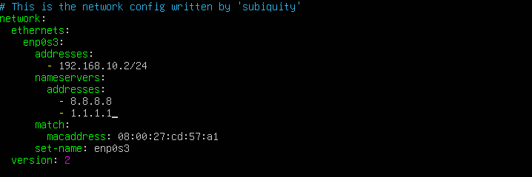
Figure 6:netplan configuration file on the Web Server
Netplan was chosen over a transient command such as ip addr add specifically because it is persistent: an address set with ip addr add is lost on reboot, requiring it to be reapplied manually every time the VM restarts, whereas a Netplan configuration is read and applied automatically at boot. This makes Netplan the more professional and reliable choice for a server that is expected to keep the same address indefinitely, which is a requirement here since Chapter 5's firewall rules and this project's inventory both depend on these addresses staying fixed.
The same configuration method is applied identically on the Management Server and Database Server — only the address and, where the underlying interface name differs, the interface identifier change; the structure and reasoning are otherwise the same for all three hosts. For this reason, only the Management Server's configuration is shown here in full; the Web Server and Database Server follow the same file with 192.168.10.2/24 and 192.168.10.3/24 respectively.

Package Installation per Role
Package requirements differ between the Management Server and the two managed servers, and this difference is a direct consequence of Ansible's agentless architecture, introduced in Section 3.1.
Management Server:
bash
sudo apt update
sudo apt install -y openssh-server ansible
Ansible itself is installed only here, since it is the control node — the tool that initiates connections and executes automation, not something that needs to run on a target.
Web Server and Database Server (identical requirements):
bash
sudo apt update
sudo apt install -y openssh-server python3

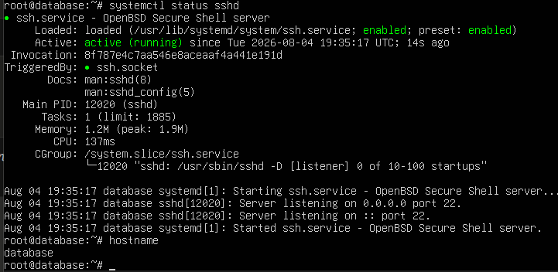
Figure 7: Verification of ssh in database server
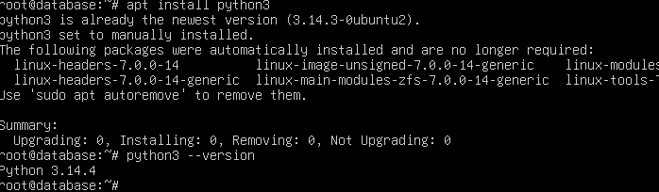
Figure 8: Verification of python3 in database server
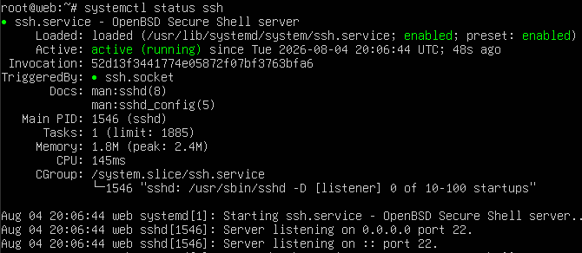
Figure 9: Verification of ssh in webserver

Figure 10: Verification of python3 in webserver
either managed server needs Ansible installed. What they do need is Python 3, because Ansible modules are executed as Python code on the target machine when a task runs — the control node connects over SSH, transfers the module, and the target executes it locally. OpenSSH is required on all three hosts, since it is the transport every Ansible connection depends on, including the Management Server's own inbound access from the administrator.

SSH Key Generation and Distribution
An SSH key pair is generated once on the Management Server and distributed to each managed host, establishing the trust relationship Ansible's connections depend on. This project uses a custom-named key rather than the default filename, to keep the automation identity clearly distinguishable from any personal SSH key on the same machine.
Key generation:
ssh-keygen -t ed25519 -f /home/ansible_user/.ssh/ansible_controle -C "ansible-control"
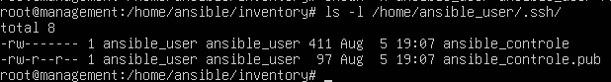
Figure 11:terminal output of key generation, showing the fingerprint
Distribution to each managed host, using -i to specify the non-default key filename explicitly:
bash
ssh-copy-id -i ~/.ssh/ansible_controle.pub ansible@192.168.10.2 # Web Server
ssh-copy-id -i ~/.ssh/ansible_controle.pub ansible@192.168.10.3 # Database Server
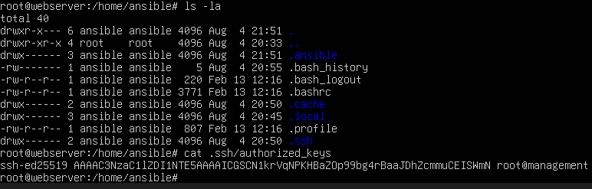
Figure 12:successful ssh-copy-id output for Web Serve
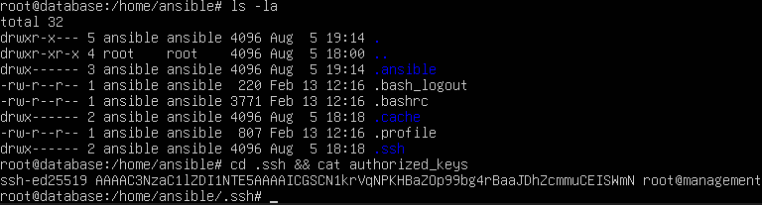
Figure 13:successful ssh-copy-id output for database Server
Manual verification, independent of Ansible, confirming the key works before any automation is attempted:
bash
ssh -i ~/.ssh/ansible_controle ansible@192.168.10.2
ssh -i ~/.ssh/ansible_controle ansible@192.168.10.3
A successful, passwordless login on both hosts confirms the key-based trust relationship is correctly established.\
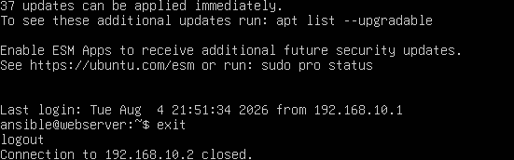
Figure 14:passwordless SSH session into Web Server
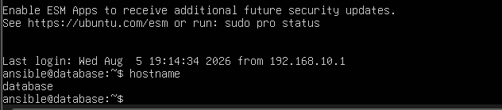
Figure 15:passwordless SSH session into database Server

Inventory, Group Variables, and Connectivity Verification
With SSH access confirmed manually, the inventory and shared connection variables are defined so that Ansible can reproduce the same access automatically, without the key path being specified on every command.
inventory/hosts.ini:
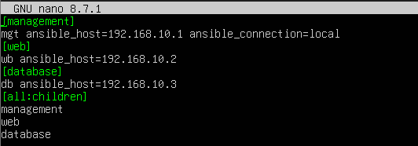
inventory/group_vars/all.yml — connection settings shared by every host, rather than repeated per line:
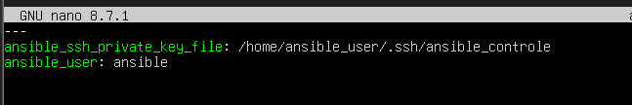
group_vars must reside inside the same directory as the inventory file for Ansible to load it automatically. Placing shared connection variables here, rather than inline in hosts.ini, keeps the inventory limited to host identity (name, address) while connection details are centralized in one place.
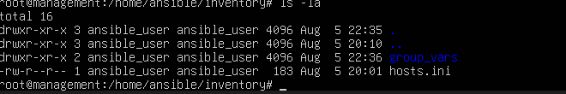
Figure 16:directory listing showing inventory/hosts.ini and inventory/group_vars/all.yml
Connectivity verification:
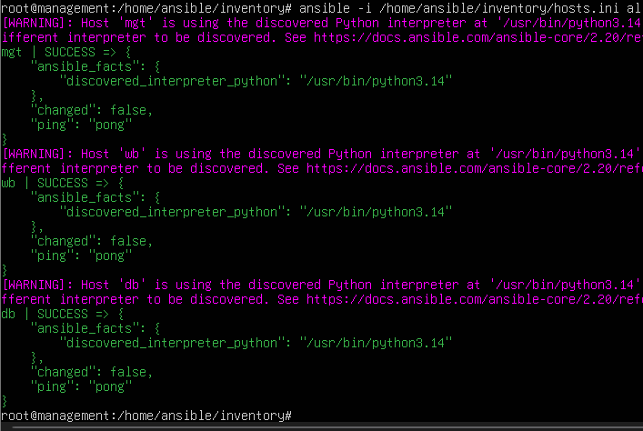
Figure 17:terminal output showing pong for mgt, web, and db
All three hosts responding pong — Management connecting locally, Web and Database Servers connecting over SSH using the distributed key and the ansible user defined in group_vars/all.yml — confirms the environment is fully reachable through Ansible. This is the chapter's closing checkpoint: Chapter 5 begins from here, applying the threat-driven framework and role-specific firewall policy to each of these three provisioned, reachable servers.

APPLYING THE FRAMEWORK: MANAGEMENT, WEB, AND DATABASE SERVERS
Chapter 2 defined the methodology; Chapter 3 defined the tooling; Chapter 4 built the environment. This chapter applies both to each server individually. Each section follows the same structure — threat model application, resulting requirements, deployment, and validation — so the same method can be seen producing genuinely different outcomes depending on the server's role.

Management Server

Why This Server Comes First
Of the three servers in this architecture, the Management Server carries the most consequence if compromised, because it is the only host with the authority to change the configuration of the other two. It does not hold application data or serve traffic — its value to an attacker is entirely the power it holds over the rest of the system, not any data stored on it directly. For this reason, its threat model and hardening are treated first, and to a stricter standard than the other two servers.

What This Server Legitimately Needs
In terms of inbound access, this server needs exactly one thing: SSH access from the administrator, authenticated by key rather than password. Nothing else should ever be allowed to initiate a connection to it — not the Web Server, not the Database Server, not any other device on the network.
In terms of outbound access, this server needs to reach the Web Server and Database Server over SSH, since that is how Ansible applies configuration. It does not need standing, permanent access to the public internet. Internet access is only useful during initial setup (installing packages) and during periodic maintenance (applying security updates) — outside of those specific moments, an always-open path to the internet serves no functional purpose and only adds risk.
This distinction matters enough to restate plainly: this server should be able to do everything it needs to do, and nothing it doesn't. Every access this server has beyond that minimum is not a convenience — it is additional risk with no corresponding benefit.

What an Attacker Would Actually Try
If someone gained a foothold on this server, their goal would not be this machine itself — it would be using this machine to reach the other two. The most direct path to that goal is not writing new attack code, but using the tools already installed and already trusted: the SSH keys already configured to reach the Web and Database Servers, and Ansible itself, which already has the standing authority to reconfigure both. An attacker with access to this server does not need to break into the Web or Database Server separately — they can simply use the access this server was built to have.
A subtler version of the same risk is tampering with the automation itself rather than the server. If an attacker quietly modified a playbook or a configuration template instead of attacking the server directly, that change would be carried out automatically the next time configuration was legitimately applied — meaning the compromise could act through the very process meant to keep the system secure. This is why the integrity of the automation code matters as much as the integrity of the server it runs on.

What Happens If It's Compromised
Compromise of this server is not contained to this server. Because it holds legitimate authority to reconfigure the Web Server and Database Server, an attacker who controls it inherits that authority rather than having to fight for it separately on each machine. This is the reasoning behind treating this server's hardening as the strictest in the architecture: the cost of getting it wrong is not local, it is total.

What This Means in Practice
Translating the reasoning above into concrete rules: inbound access is limited to SSH from the administrator only, with everything else denied, including any connection attempt from the Web or Database Server toward this machine — since control flow in this architecture only ever moves outward from here, never back. Outbound access is limited to SSH toward the Web and Database Servers specifically. Internet access for updates is not left permanently open; it is enabled deliberately when needed and closed again afterward, so that this server's connection to the internet exists only for as long as it is actually being used, rather than as a standing, unattended capability.

Configuration Implementation
The requirements defined in Section 5.1.2 are translated into enforced configuration through the role structure introduced in Chapter 3. This section presents that implementation in the order it is actually built: the policy data first, the logic that consumes it, the mechanism that deploys it, and finally the playbook that ties it to this host.

The Firewall Policy Template
The actual firewall logic is written once, in roles/firewall/templates/nftables.conf.j2, and shared across every server role in this project. It contains no server-specific values itself — every address and port is supplied by whichever host's variables are active at render time.
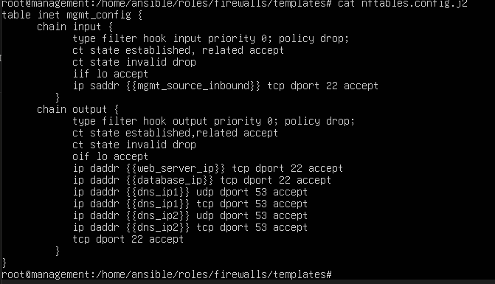
Figure 18: roles/firewalls/templates/nftables.config.j2
Both chains open with type filter hook input/output priority 0; policy drop;, enforcing deny-by-default on this host — nothing passes unless an explicit rule below it permits it. ct state established,related accept allows return traffic belonging to a connection this host itself opened, and ct state invalid drop explicitly discards packets that do not correspond to any known connection state, closing off a class of malformed or spoofed traffic before it reaches any other rule. iif lo / oif lo accept permit loopback traffic, required for local processes on the host to communicate with themselves.
The input chain contains a single rule beyond these baseline protections: SSH from {{mgmt_source_inbound}} only, matching the single legitimate inbound path identified in Section 5.1.2 — the administrator, and nothing else.
The output chain's first two rules — SSH to {{web_server_ip}} and {{database_ip}} — are the direct implementation of this server's role as the Ansible control node, matching Section 5.1.2 exactly.
Justification for DNS, HTTPS, and GitHub SSH Access
Beyond the two SSH rules derived directly from this server's role as the Ansible control node, the remaining outbound rules — DNS toward two resolvers, HTTPS, and SSH scoped to GitHub — do not originate from the threat model in Sections 2.2 and 5.1.2. They exist for a separate and explicitly acknowledged reason: this project's configuration is version-controlled and maintained on GitHub, which requires the Management Server to reach the outside world for that specific purpose. DNS resolution is a precondition for locating GitHub's servers by hostname rather than a hardcoded address, which is why two resolvers are permitted rather than relying on a single point of failure. HTTPS is required for any interaction with GitHub's web-facing services (cloning over HTTPS, API calls, or web-based operations), while the SSH rule, scoped specifically to GitHub's address, is required for pushing and pulling the repository over git@github.com, which this project uses for its own version control. Each of these rules is deliberately scoped to GitHub's known address rather than left open to arbitrary destinations, so that this operational need is met without reintroducing the unrestricted outbound access the threat model explicitly ruled out. It is stated here plainly, rather than left to blend into the rest of the ruleset, that these rules reflect a development and documentation workflow requirement of building this project — not a requirement the Management Server's security role itself produces. Conflating the two would misrepresent the threat model as having justified access it did not actually justify.

Policy Variables
This host's configuration is split across two variable files, reflecting the distinction between connection mechanics and security policy established earlier in this project. inventory/group_vars/all.yml holds the settings shared by every host in the inventory, since Ansible's method of connecting — which key, which user — does not change per server role:
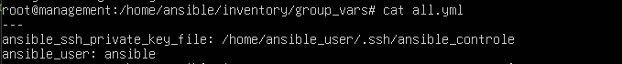
Figure 19: inventory/group_vars/all.yml
inventory/group_vars/management.yml holds the values specific to this server's role and its firewall policy, matching the [management] inventory group by filename:
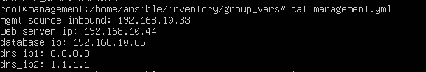
Figure 20: inventory/group_vars/management.yml
mgmt_source_inbound, web_server_ip, and database_ip are the direct encoding of the requirement set derived in Section 5.1.2 — the administrator's permitted source and the two managed servers this host is authorized to reach. dns_ip1 and dns_ip2 supply the values used by the DNS rules justified separately in Section 5.1.5.4; their presence in this file is a matter of implementation convenience rather than evidence that the threat model itself produced them, a distinction already stated where those rules are justified. Keeping connection settings in all.yml and security policy in management.yml means a change to one category — for example, rotating the SSH key — never risks an accidental edit to the other.

Deployment Task
The task in roles/firewall/tasks/main.yml deploys the rendered configuration and applies it:
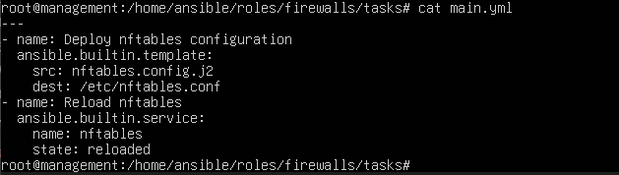
Figure 21:roles/firewall/tasks/main.yml file contents
The first task renders the template using this host's variables and writes the result to /etc/nftables.conf. The second task then reloads the nftables service so the new configuration is actually loaded into the kernel's active ruleset — writing the file alone would have no effect on traffic without this step.
No Ansible handler is used in this implementation. A handler would allow the reload to run only when the template task actually changes the configuration file, rather than on every playbook execution regardless of whether anything changed. This project reloads nftables unconditionally on every run instead, which is functionally correct but marginally less efficient — a genuine trade-off, stated here deliberately rather than presented as an oversight. Given the small scale of this environment and the infrequency of playbook runs, the cost of this simplification is negligible in practice.

Playbook
site.yml connects the role above to its target host group:
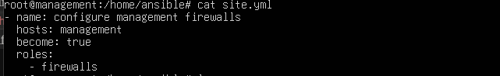
Figure 22:site.yml file contents
become: true is required because writing /etc/nftables.conf and reloading the nftables service both require root privileges, obtained through sudo rather than direct root login, consistent with the access model established earlier in this project. hosts: management restricts this play to the Management Server specifically, using the inventory group defined in Chapter 4.

Deployment and Validation
The playbook is deployed from the Management Server's project directory, specifying the inventory explicitly:
bash
ansible-playbook -i inventory/hosts.ini site.yml
Since site.yml targets hosts: management, this command applies the firewalls role to the Management Server only, without needing an additional --limit flag — the play itself already scopes execution to this one host via the inventory group. Running it executes both tasks defined in Section 5.1.5.5 in sequence: the template is rendered using the variables from management.yml and written to /etc/nftables.conf, and the nftables service is then reloaded, applying the new ruleset immediately. This command was run repeatedly throughout development of this server's configuration; its effect is verified below directly against the live system, rather than against the command's own console output.
Ruleset verification — confirming the active configuration matches what was intended:
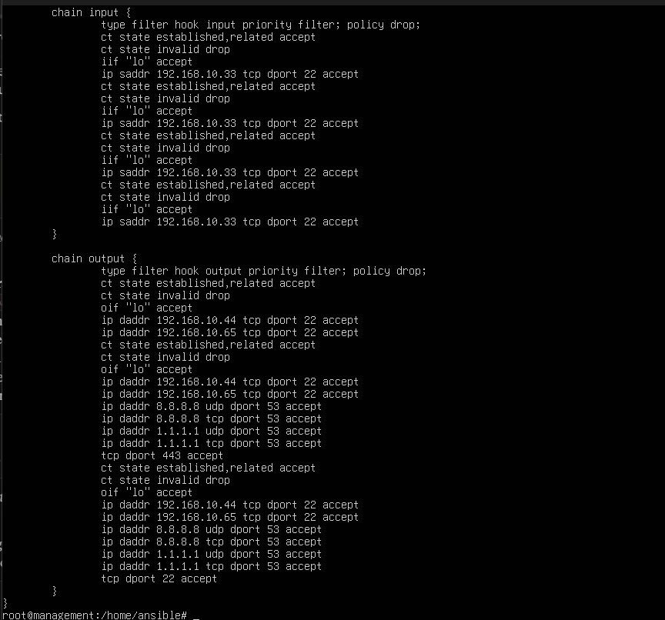
Figure 23:nft list ruleset output on the Management Server, matching the rendered template

Web Server

Why This Server Sits Between the Other Two
Of the three servers in this architecture, the Web Server occupies a distinct position: it is the only host designed to be reached by unknown, unauthenticated parties. The Management Server's risk comes from the authority it holds; the Database Server's risk comes from the data it stores. The Web Server's risk comes from something neither of the others share — it must remain reachable by anyone, by definition, which means the entry point itself cannot be closed the way it can on the other two hosts. For this reason, its hardening focuses less on restricting who can reach it and more on restricting what it can do once reached.

What This Server Legitimately Needs
In terms of inbound access, this server needs two distinct things, each on a different network path. It needs to accept HTTP and HTTPS connections from anyone, on the interface facing outward — this is not a risk to be minimized, it is the server's actual purpose. Separately, it needs to accept SSH access from the Management Server only, on the interface facing the internal network, so that Ansible can apply configuration. These two needs are kept deliberately separate: the interface that accepts the public should never be the same interface that accepts administrative access.
In terms of outbound access, this server needs to reach the Database Server, and nothing else. It does not need standing internet access. Package updates, where needed, are enabled deliberately by an administrator and closed again afterward, the same principle applied to the Management Server — an always-open outbound path serves no function here and only expands what a compromised process could reach.

What an Attacker Would Actually Try
Unlike the Management Server, where a foothold requires stealing a credential, this server's entry point is open by design — the realistic path to compromise is exploiting whatever is actually running behind ports 80 and 443: a vulnerable application, an outdated package, a flaw in how input is handled. Once code execution is achieved here, the attacker's next move is not to attack this server further, but to use it as a stepping stone toward the Database Server, attempting to reach it over whatever outbound path this host has been given. This is precisely why the outbound side of this server's configuration matters more than the inbound side — the inbound side is necessarily open, so the outbound side is where containment actually happens.

What Happens If It's Compromised
Unlike the Management Server, compromise here does not automatically cascade. If outbound access is correctly restricted to only the Database Server, on only the port that server's application needs, an attacker who gains a foothold here inherits a foothold — not a path to the rest of the architecture. This is the deliberate design outcome: this server is the one most likely to face an attack attempt, precisely because it is reachable, and its hardening is built around the assumption that reachability may eventually be exploited, rather than the assumption that it won't be.

What This Means in Practice
Translating the reasoning above into concrete rules: inbound access accepts HTTP and HTTPS from any source, but only on the interface facing outward, and accepts SSH only from the Management Server's address, only on the interface facing the internal network — the same rule could not be enforced correctly without this separation, since a source-address check alone cannot distinguish which physical path a claimed address actually arrived on. Outbound access is limited to the Database Server, on its designated port, and nothing else — no standing internet access, no exception carried over from the inbound side's necessary openness. Any outbound attempt beyond the Database Server is treated as an anomaly, since this host has no other legitimate reason to initiate a connection at all.

Configuration Implementation

Firewall Policy Template
The Web Server's ruleset is one section of the shared template used across this project, roles/firewalls/templates/nftables.config.j2, isolated by a condition checking the host's inventory group membership:
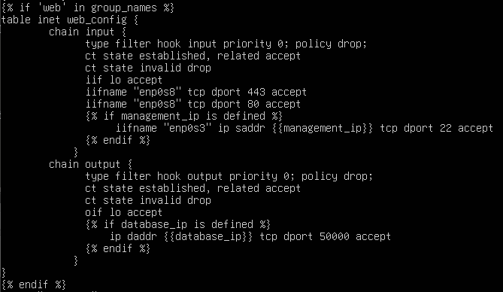
Figure 24: roles/firewalls/templates/nftables.config.j2
The {% if 'web' in group_names %} condition ensures this table is only rendered when Ansible is processing a host that genuinely belongs to the [web] inventory group; when the same shared template is rendered for the Management or Database Server, this block is skipped, and their own conditioned sections apply instead. Rules are scoped per interface using iifname and oifname, reflecting this host's two adapters: enp0s9, facing outward, and enp0s8, connected to the internal network. This ensures an inbound SSH attempt claiming to originate from the Management Server's address is rejected outright if it arrives on the outward-facing interface — the interface itself is checked, not only the claimed source address.

Deployment Task
The task and handler structure is identical to the one defined for the Management Server in Section 5.1.5 — the same firewalls role deploys the same rendered template and reloads nftables unconditionally, with the only difference being which host the play targets. It is not repeated here in full; see Section 5.1.5 for the task definition.

Playbook

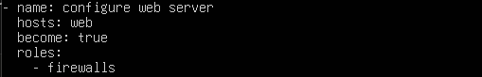
Figure 25: ansible/site.yml for web server
hosts: web restricts this play to the Web Server exclusively, using the inventory group defined in Chapter 4.

Deployment and Validation
We execute the playbook usiing the following command:
ansible-playbook -i inventory/hosts.ini site.yml
Since site.yml contains a separate play per host group, this single command executes both the Management and Web Server configurations in sequence, each correctly scoped by its own hosts: targeting.
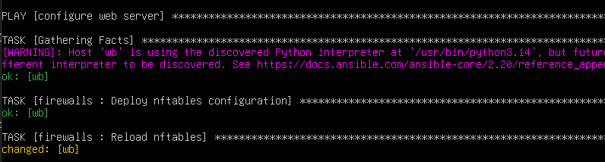
Figure 26: playbook execution on webserver

Ruleset verification:
confirming the deployed configuration on the host matches the intended policy:
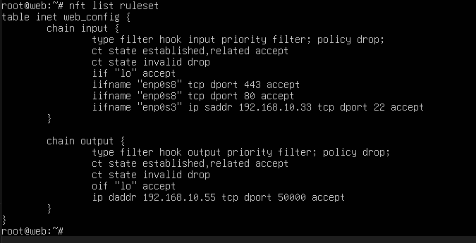
Figure 27:nft list ruleset output on the Web Server
The output shows the web_config table applied, with HTTP and HTTPS accepted on the outward-facing interface and SSH accepted only from the Management Server's address on the internal interface, matching Section 5.2.5's stated rules exactly

Database Server

Why This Server Is Treated Differently
Of the three servers in this architecture, the Database Server is the only one with no legitimate reason to initiate any connection at all. The Management Server must reach outward to configure others; the Web Server must reach outward to query its data store. The Database Server only ever responds — it never needs to ask anything of anyone. This asymmetry is not incidental, and it shapes this server's hardening more than any other single fact: a host that never needs to speak outbound can have its outbound access denied entirely, with no operational exception required.

What This Server Legitimately Needs
In terms of inbound access, this server needs exactly two things: application queries from the Web Server, on the database's designated port, and configuration access from the Management Server, over SSH. Nothing else has any legitimate reason to reach this host — not the administrator directly, not any device outside this architecture.
In terms of outbound access, this server needs nothing. It holds the most sensitive asset in the architecture — the data itself — and it accomplishes its entire function without ever needing to reach anywhere on its own initiative. Unlike the Management Server and Web Server, no maintenance-window exception is made here for updates or DNS; this server's outbound side stays closed under every circumstance addressed by this project.

What an Attacker Would Actually Try
Since this server holds the most valuable asset in the architecture, the realistic goal of an attacker who gained a foothold here would be exfiltration — getting the data out. This is precisely where a fully closed outbound chain matters most: even a successful compromise at the application or OS level on this host would find no standing channel through which to send data anywhere. The attacker would be forced to either abuse the one open channel (querying back through the Web Server's own connection) or attempt to open a new outbound path themselves — an action that, on this host, is itself the anomaly, since no such action should ever occur under normal operation.

What Happens If It's Compromised
Direct and severe for the confidentiality of the data itself, but contained in its reach. Unlike the Management Server, whose compromise cascades to every other host, and unlike the Web Server, whose compromise could pivot onward if outbound access were too permissive, a Database Server compromise under this architecture cannot itself become a foothold toward anything else — there is nowhere for it to go.

What This Means in Practice
Translating the reasoning above into concrete rules: inbound access accepts application traffic from the Web Server's address, on the database's designated port, and SSH from the Management Server's address, and nothing else. Outbound access permits only the baseline traffic required for the connection itself to function — established and related traffic, and loopback — with no additional exception of any kind. This is the strictest ruleset in the architecture, and deliberately so: this is the one host where the cost of an unnecessary exception is not proportional to convenience gained, since this server was never meant to initiate anything in the first place.

Configuration Implementation

Firewall Policy Template
The Database Server's ruleset is the final section of the shared template, isolated by the same group-membership condition used for the other two hosts:
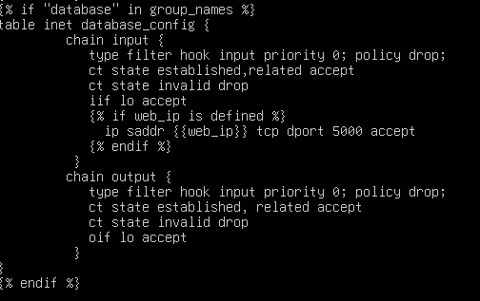
Figure 28: rendered /etc/nftables.conf on the Database Server
No interface scoping (iifname/oifname) is applied here, unlike the Web and Management Servers. This is a deliberate omission rather than an inconsistency: this host has only one network interface, so a rule restricting traffic by interface would add no additional protection beyond what the source-address restriction already provides — there is no second, more exposed interface for such a rule to meaningfully exclude.

The task, handler, and playbook
The task, handler, and playbook structure are identical to those used for the Management and Web Servers, differing only in which host group the play targets; they are not repeated here in full.
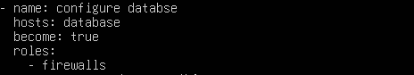
Figure 29: ansible/site.yml for the database

Deployment and Validation
With this final play added, one command now deploys and applies the correct, distinct configuration to all three servers in a single run, each host's own conditioned section of the shared template applying automatically based on its inventory group membership.
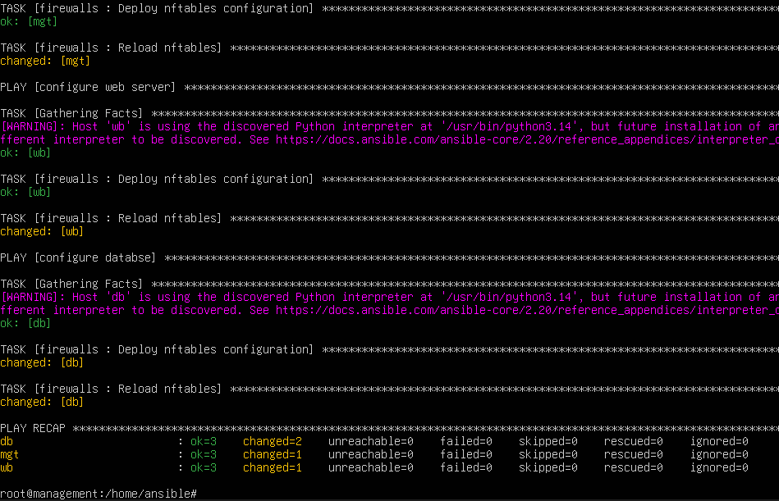
Figure 30: ansible_playbook_all_hosts_deployment
Figure 31: the

Ruleset verification
confirming the deployed configuration matches the intended policy, specifically the absence of any outbound rule beyond the baseline:
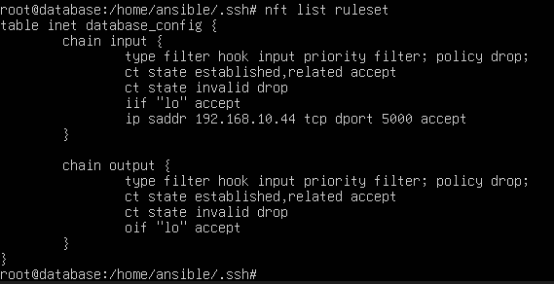
Figure 32: nft list ruleset output on the Database Server
The output confirms that the output chain contains no rule beyond established/related traffic and loopback — no destination, however permitted elsewhere in this project, is reachable from this host as a newly initiated connection.

